CONDENSED CONSOLIDATED STATEMENTS OF COMPREHENSIVE INCOME (UNAUDITED)
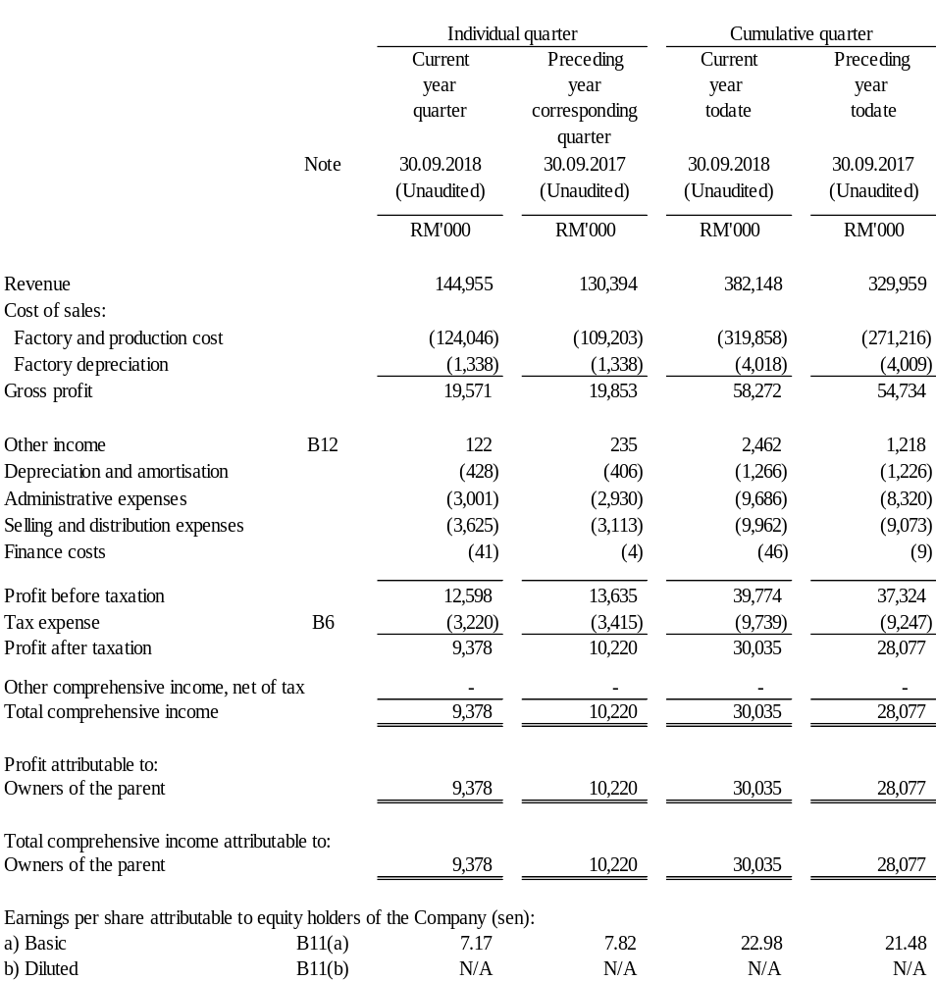

(The condensed consolidated income statements should be read in conjunction with the audited financial statements for the year ended 31 December 2017 and the accompanying explanatory notes attached to the interim financial statements).

CONDENSED CONSOLIDATED STATEMENTS OF FINANCIAL POSITION (UNAUDITED)

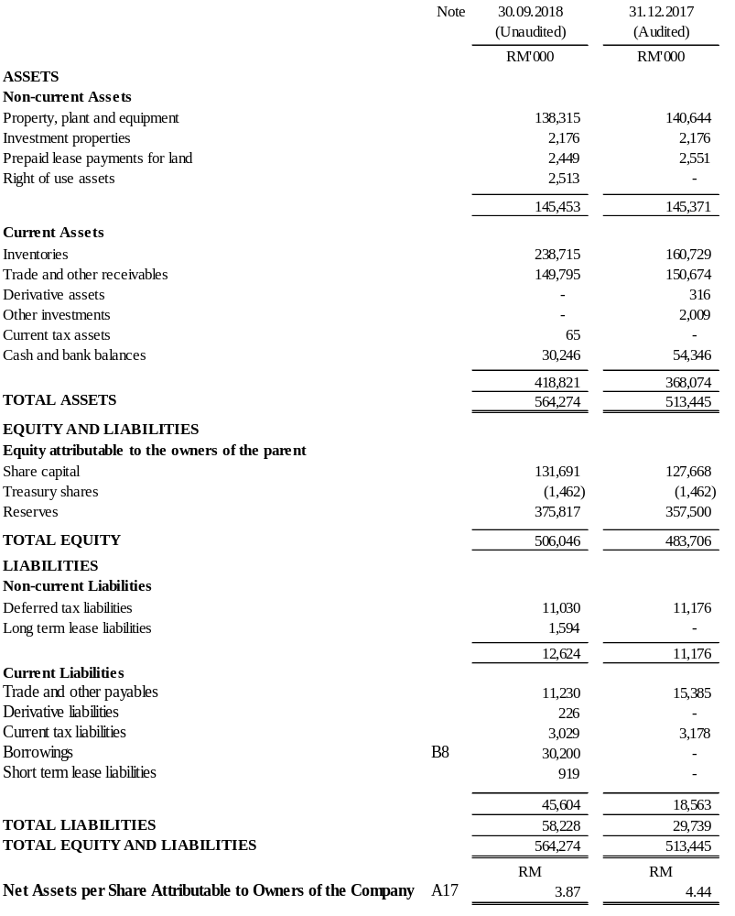
(The condensed consolidated statements of financial position should be read in conjunction with the audited financial statements for the year ended 31 December 2017 and the accompanying explanatory notes attached to the interim financial statements).
CONDENSED CONSOLIDATED STATEMENTS OF CASH FLOWS FOR THE PERIOD ENDED 30 SEPTEMBER 2018 (UNAUDITED)

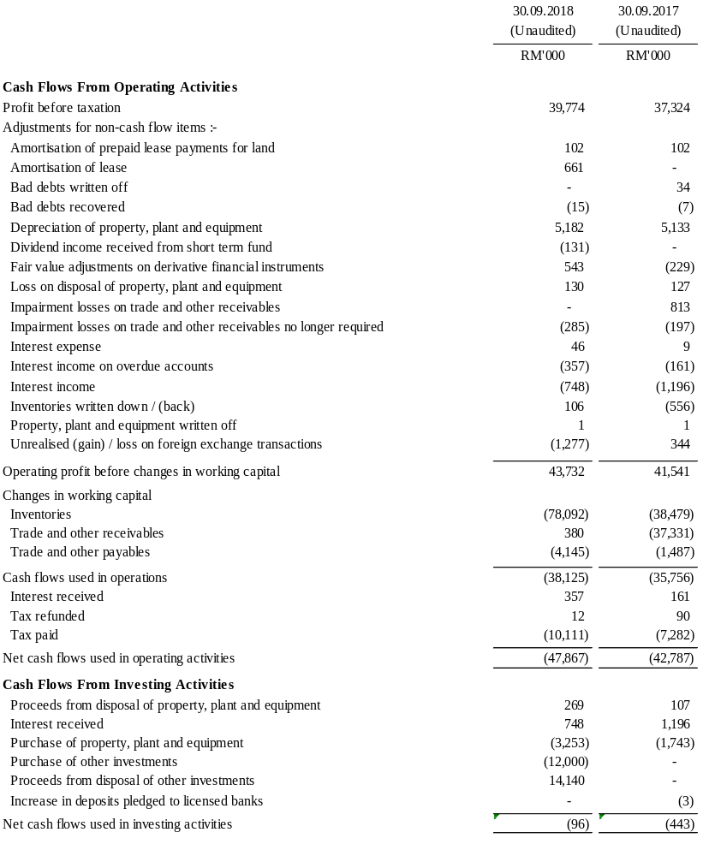

CONDENSED CONSOLIDATED STATEMENTS OF CASH FLOWS FOR THE PERIOD ENDED 30 SEPTEMBER 2018 (UNAUDITED) (CONT’D)

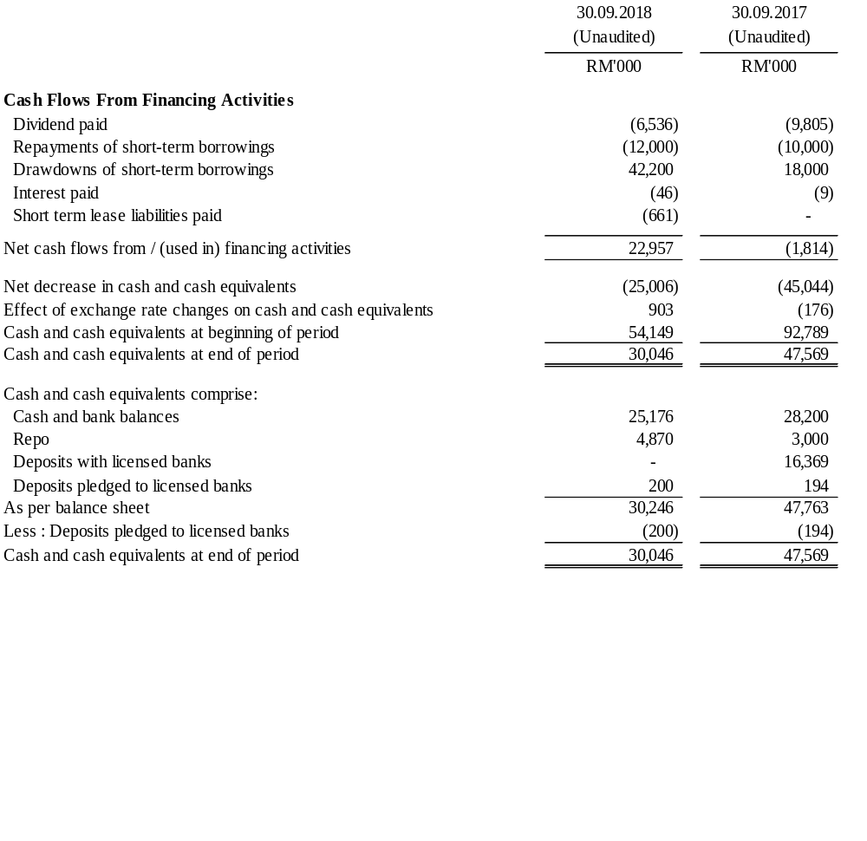

(The condensed consolidated statements of cash flow should be read in conjunction with the audited financial statements for the year ended 31 December 2017 and the accompanying explanatory notes attached to the interim financial statements).
CONDENSED CONSOLIDATED STATEMENT OF CHANGES IN EQUITY (UNAUDITED)
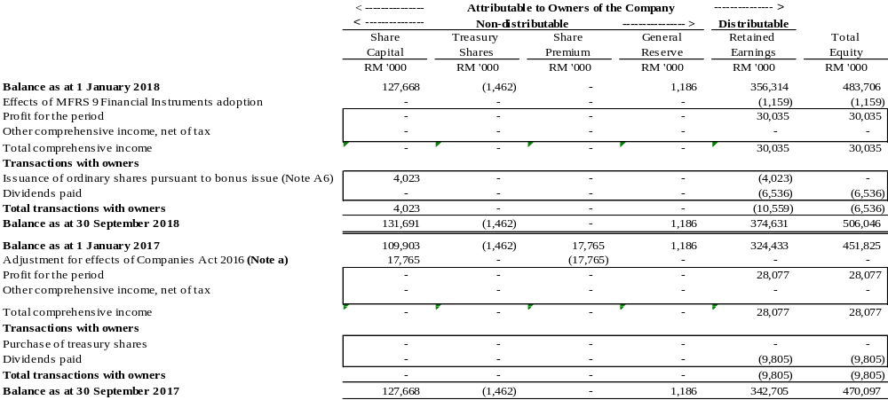
Note a
The credit standing in the share premium account of RM17,765,000 were transferred to the share capital account on the commencement of the Companies Act 2016 (“New Act”) on 31 January 2017. Pursuant to subsection 618(3) of the New Act, the credit amount transferred from the share premium account was fully utilised for the bonus issue of the company as disclosed in note A6.

(The condensed consolidated statements of changes in equity should be read in conjunction with the audited financial statements for the year ended 31 December 2017 and the accompanying explanatory notes attached to the interim statements).
EXPLANATORY NOTES PURSUANT TO THE MALAYSIAN FINANCIAL REPORTING STANDARD (“MFRS”) 134: INTERIM FINANCIAL REPORTING

A1 Basis of preparation
The interim financial statements, other than for financial instruments and investment properties, have been prepared under the historical cost convention. Certain financial instruments have been carried at fair value in accordance to MFRS 139 Financial Instruments: Recognition and Measurement, while investment properties are stated at fair value as per MFRS 140 : Investment Property.

The interim financial statements also has been prepared in accordance with MFRS 134 : Interim Financial Reporting and paragraph 9.22 of the Main Market Listing Requirements of Bursa Malaysia Securities Berhad (Bursa Malaysia).

This interim financial statements should be read in conjunction with the audited financial statements for the financial year ended 31 December 2017 of the Group and the accompanying notes attached to the interim financial report. The accounting policies adopted in the preparation of the interim financial statements are consistent with those followed in the preparation of the Group's audited financial statements for the financial year ended 31 December 2017, except for the adoption of the Amendments and Annual improvements to Standards effective as of 1 January 2018.

(i) MFRSs, Amendments and Annual Improvements to MFRSs and IC Interpretations adopted by the Group during the current financial period:

MFRSs, Amendments and Annual Improvements to MFRSs and IC Interpretations |  | Effective for annual periods beginning on or after
MFRS 9 | : Financial Instruments (IFRS 9 as issued by International Accounting Standards Board (“IASB”) in July 2014) | 1 January 2018
MFRS 15 | : Revenue from Contracts with Customers  : Clarification to MFRS 15 | 1 January 2018
Amendments to MFRS 4 | : Applying MFRS 9 Financial Instruments with MFRS 4 Insurance Contracts | 1 January 2018
Amendments to MFRS 140 | : Transfers of Investment Property | 1 January 2018
IC Interpretation 22 | : Foreign Currency Transactions and Advance Consideration | 1 January 2018

The adoption of the above MFRSs, Amendments and Annual Improvements to MFRSs and IC Interpretations does not have any impact on the Group, except the following:

A1 Basis of preparation (Cont’d)
- MFRSs, Amendments and Annual Improvements to MFRSs and IC Interpretations adopted by the Group during the current financial period (Cont’d):

MFRS 9 Financial Instruments
The adoption of this standard resulted in changes in accounting policies and adjustments to the financial statements. The accounting policies that relate to the recognition, classification, measurement and derecognition of financial instruments and impairment of financial assets were amended to comply with the provisions in the standard. In accordance with the transition requirements under paragraph 7.2.15 of this standard, comparatives are not restated and the financial impact of the adoption of this standard is recognized in retained earnings as at 1 January 2018.

- Changes in accounting policies
Financial assets
The Group classifies its financial assets into the following measurement categories:
- Those to be measured subsequently at fair value either through other comprehensive income or through profit or loss; and
- Those to be measured at amortised cost.

The classification above depends on the Group’s business model for managing the financial assets and the contractual terms of cash flows. The following summaries the key changes:
- The loans and receivables financial asset category was removed.
- A new asset category measured at amortised cost was introduced. This applies to financial assets with contractual cash flow characteristics that are solely payments of principal and interests and held in a business model whose objective is achieved by collecting contractual cash flows only.

Financial liabilities
There is no impact on the classification and measurement of the Group’s financial liabilities.

Impairment of financial assets
MFRS 9 Financial Instruments requires impairment assessments to be based on an Expected Credit Loss (“ECL”) model, replacing the incurred loss model under MFRS 139. The key changes in the Group’s accounting policies for impairment of financial assets are as follows:
- Trade and other receivables, net of prepayments
The Group applies the simplified approach prescribed by MFRS 9 Financial Instruments, which requires expected lifetime losses to be recognised from initial recognition of the trade and other receivables which are financial assets.

A1 Basis of preparation (Cont’d)
- MFRSs, Amendments and Annual Improvements to MFRSs and IC Interpretations adopted by the Group during the current financial period (Cont’d):

- Classification and measurement of financial instruments
The following table summarises the reclassification and measurement of the Group’s financial assets as at 1 January 2018:
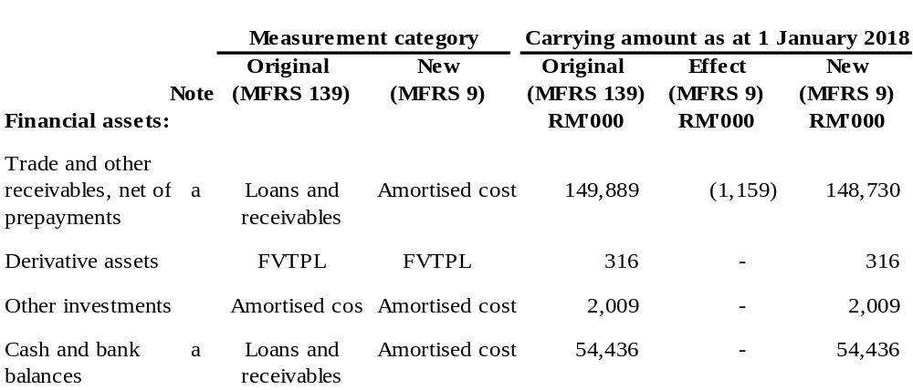
- Early adoption of MFRSs, Amendments and Annual Improvements to MFRSs and IC Interpretations adopted by the Group during the current financial period:

Effective for financial periods beginning on or after 1 January 2019

MFRS 16 Leases

The Group has early adopted MFRS 16 Leases and applied this Standard retrospectively during the financial period. In accordance with the transition requirements under the Appendix C, paragraph 5(b) of this Standard, comparatives are not restated.

As a result of the adoption of MFRS 16 Leases, the existing requirements for a lessee to distinguish between finance lease and operating lease under the MFRS 117 Leases are no longer required. This Standard introduces a single accounting model, requiring the lessee to recognise the right-of-use of the underlying lease asset and the future lease payments liabilities in the statement of financial position. For a lessor, MFRS 16 Leases continue to allow the lessor to classify leases as either operating leases or finance leases and to account for these two types of leases differently.

A1 Basis of preparation (Cont’d)
- Early adoption of MFRSs, Amendments and Annual Improvements to MFRSs and IC Interpretations adopted by the Group during the current financial period (Cont’d):

The following table presents the impact of changes to the consolidated Statements of Financial Position of the Group resulting from the early adoption of MFRS 16 Leases as at 1 January 2018:
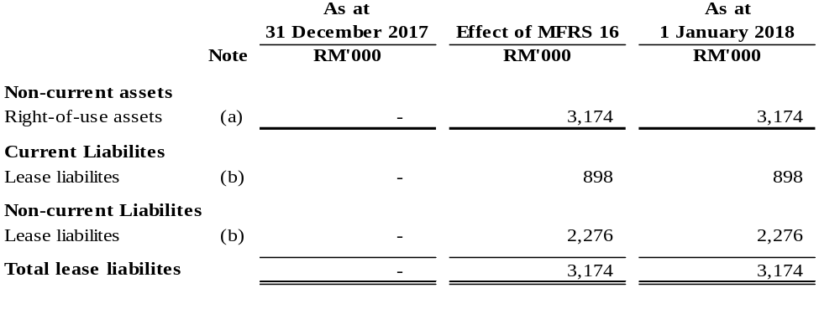Note:
- The right of use assets comprises multiple pieces of land and building leased and recognised during the period. Subsequent to initial recognition, the right of use assets are measured at cost less any accumulated depreciation, accumulated impairment losses and adjusted for any remeasurement of lease liabilities.
- The lease liabilities arising from the land and building leased are recognised and discounted using the Group's incremental borrowing rate of 3.93%. Subsequent to initial recognition, the Group measures the lease liabilities by increasing the carrying amount to reflect the interest on the lease liabilities, reducing the carrying amount to reflect lease payments made and remeasuring the carrying amount to reflect any reassessment or lease modifications.

- MFRSs, Amendments and Annual Improvements to MFRSs and IC Interpretations issued but not yet effective

At the date of authorisation of these interim financial statements, the following MFRSs, Amendments and Annual Improvements to MFRSs and IC Interpretations were issued but not yet effective and have not been adopted by the Group:

MFRSs, Amendments and Annual Improvements to MFRSs and IC Interpretations |  | Effective for annual periods beginning on or after
Amendments to MFRS 9 | : Prepayment Features with Negative Compensation | 1 January 2019
Amendments to MFRS 119 | : Plan Amendment, Curtailment or Settlement | 1 January 2019
Amendments to MFRS 128 | : Long-term Interests in Associates and Joint Ventures | 1 January 2019

A1 Basis of preparation (Cont’d)
- MFRSs, Amendments and Annual Improvements to MFRSs and IC Interpretations issued but not yet effective (Cont’d)

MFRSs, Amendments and Annual Improvements to MFRSs and IC Interpretations |  | Effective for annual periods beginning on or after
Annual Improvements to  MFRSs 2015 – 2017 Cycle | : Amendments to MFRS 3 – Previously Held Interest in a Joint Operation  : Amendments to MRFS 11 – Previously Held Interest in a Joint Operation  : Amendments to MRFS 112 – Income Tax Consequences of Payments on Financial Instruments Classified as Equity  : Amendments to MFRS 123 – Borrowing Costs Eligible for Capitalisation | 1 January 2019
IC Interpretation 23 | : Uncertainty over Income Tax Treatments | 1 January 2019
Amendments to MFRS 2 | : Share-based Payment | 1 January 2020
Amendments to MFRS 3 | : Business Combinations | 1 January 2020
Amendments to MFRS 6 | : Exploration for and Evaluation of Mineral Resources | 1 January 2020
Amendments to MFRS 14 | : Regulatory Deferral Accounts | 1 January 2020
Amendments to MFRS 101 | : Presentation of Financial Statements | 1 January 2020
Amendments to MFRS 108 | : Accounting Policies, Changes in Accounting Estimates and Errors | 1 January 2020
Amendments to MFRS 134 | : Interim Financial Reporting | 1 January 2020
Amendments to MFRS 137 | : Provisions, Contingent Liabilities and Contingent Assets | 1 January 2020
Amendments to MFRS 138 | : Intangible Assets | 1 January 2020
Amendments to IC  Interpretation 12 | : Service Concession Arrangements | 1 January 2020
Amendments to IC  Interpretation 19 | : Extinguishing Financial Liabilities with Equity Instruments | 1 January 2020
Amendments to IC  Interpretation 20 | : Stripping Costs in the Production Phase of a Surface Mine | 1 January 2020
Amendments to IC  Interpretation 22 | : Foreign Currency Transactions and Advance Consideration | 1 January 2020
Amendments to IC  Interpretation 132 | : Intangible Assets – Web Site Costs | 1 January 2020
MFRS 17 | : Insurance Contracts | 1 January 2021
Amendments to MFRS 10  And MFRS 128 | : Sale or Contribution of Assets between an Investor and its Associate or Joint Venture | Deferred

A1 Basis of preparation (Cont’d)
- MFRSs, Amendments and Annual Improvements to MFRSs and IC Interpretations issued but not yet effective (Cont’d)

Amendments to MFRS 9 Prepayment Features with Negative Compensation
The amendments addresses the measurement of some prepayable financial assets with negative compensation at amortised cost. The assets affected, that include some loans and debt securities, would otherwise have been measured at fair value through profit or loss (FVTPL). Negative compensation arises where the contractual terms permit the borrower to prepay the instrument before its contractual maturity, but the prepayment amount could be less than unpaid amounts of principal and interest. However, to qualify for amortised cost measurement, the negative compensation must be “reasonable compensation for early termination of the contract”. In addition, to qualify for amortised cost measurement, the asset must be held within a “held to collect” business model.

Amendments to MFRS 119 Plan Amendment, Curtailment or Settlement
The amendments clarify that when a plan amendment, curtailment or settlement occurs, an entity shall recognise and measure any past service cost, or gain or loss on settlement and shall not consider the effect of the asset ceiling. The effect of the asset ceiling shall be determine after the plan amendment, curtailment or settlement and shall recognise any change in that effect.

Amendments to MFRS 128 Investments in Associates and Joint Ventures
The amendments clarify that companies should apply IFRS 9 (including its impairment requirements) to account for long-term interests in an associate or a joint venture to which the equity method is not applied.

Annual Improvements to MFRS Standards 2015 - 2017 Cycle
a. Amendments to MFRS 3 – Business Combinations
The amendments clarify that when an entity obtains control of a business that is a joint operation, it shall remeasure its previously held interest in the joint operation at fair value.

b. Amendments to MFRS 11 – Joint Arrangements
The amendments clarify that when an entity obtains joint control of the joint operation in which the activity of the joint operation constitutes a business as defined in MFRS 3, the previously held interest is not remeasured.

c. Amendments to MFRS 112 – Income Taxes
The amendments clarify that all income tax consequences of dividends (including payments on financial instruments classified as equity) are recognised consistently with the transactions that generated the distributable profits i.e. in profit or loss, other comprehensive income or equity.

d. Amendments to MFRS 123 – Borrowing Costs
The amendments clarify that when a qualifying asset is ready for its intended use or sale, an entity shall treat any outstanding borrowing made specifically to obtain that qualifying asset as part of general borrowings. This means that the amount of borrowing costs that an entity capitalises during a period shall not exceed the amount of borrowing costs it incurred during that period.

The adoption of Annual Improvements to MFRS Standards 2015 - 2017 Cycle is not expected to have any financial impact on the financial statements of the Group.

A1 Basis of preparation (Cont’d)
- MFRSs, Amendments and Annual Improvements to MFRSs and IC Interpretations issued but not yet effective (Cont’d)

IC Interpretation 23 – Uncertainty over Income Tax Treatments
The IC Interpretation provides clarification on the application of recognition and measurement requirements in MFRS 112 Income Taxes when there is uncertainty over income tax treatments. The IC interpretation clarifies that an entity shall:

- assume that a taxation will examine amounts it has a right to examine and have full knowledge of all related information when making those examinations.
- reflect the effect of uncertainty in determining the related tax position (using either the most likely amount method or the expected value method) if it concludes it is not probable that the taxation authority will accept an uncertain tax treatment.

The adoption of the IC Interpretation is not expected to have any material financial impact on the financial statements of the Group.

Amendments to MFRS 2 Share-based Payment
Amendments to MFRS 3 Business Combinations
Amendments to MFRS 6 Exploration for and Evaluation of Mineral Resources
Amendments to MFRS 14 Regulatory Deferral Accounts
Amendments to MFRS 101 Presentation of Financial Statements
Amendments to MFRS 108 Accounting Policies, Changes in Accounting Estimates and Errors
Amendments to MFRS 134 Interim Financial Reporting
Amendments to MFRS 137 Provisions, Contingent Liabilities and Contingent Assets
Amendments to MFRS 138 Intangible Assets
Amendments to IC Interpretation 12 Service Concession Arrangements
Amendments to IC Interpretation 19 Extinguishing Financial Liabilities with Equity Instruments
Amendments to IC Interpretation 20 Stripping Costs in the Production Phase of a Surface Mine
Amendments to IC Interpretation 22 Foreign Currency Transactions and Advance Consideration
Amendments to IC Interpretation 132 Intangible Assets – Web Site Costs
The international Accounting Standards Board (the IASB or the Board) issued the revised Conceptual Framework for Financial Reporting (the revised Conceptual Framework) on 29 March 2018. The revised version included comprehensive changes to the previous Conceptual Framework, issued in 1989 and partly revised version in 2010. The previous Conceptual Framework (the 2010 Conceptual Framework) was criticised for its lack of clarity, the exclusion of certain important concepts and for being outdated in terms of the IASB’s current thinking. Following the IASB’s agenda consultation in 2011, the Conceptual Framework project was added to the IASB’s work plan in September 2012. Since then, the IASB has issued a discussion paper in July 2013 and an exposure draft in June 2015. In revising the Conceptual Framework, the Board was looking to underpin high level concepts with sufficient detail for it to set standards and to help others to better understand and interpret the standards.

The above amendments, which forms the “Amendments to References to the Conceptual Framework in IFRS Standards”, sets out the amendments to affected standards in order to update references to the revised Conceptual Framework. In most cases, the standard references are updated to refer to the revised Conceptual Framework. However, there are two exemptions, one for IFRS 3 Business Combinations and one for those applying IAS 8 Accounting Policies, Changes in Accounting Estimates and Errors in developing accounting policies for regulatory account balances.

A1 Basis of preparation (Cont’d)
- MFRSs, Amendments and Annual Improvements to MFRSs and IC Interpretations issued but not yet effective (Cont’d)

The adoption of the above Amendments to References to the Conceptual Framework in IFRS Standards are not expected to have any material financial impact on the financial statements of the Group.

MFRS 17 Insurance Contracts
MFRS 17 introduces consistent accounting for all insurance contracts based on a current measurement model. Under MFRS 17, the general model requires entities to recognise and measure a group of insurance contracts at:

- a risk-adjusted present value of future cash flows that incorporates information that is consistent with observable information; plus
- an amount representing the unearned profit in the group of contracts.

The adoption of MFRS 17 will not have any material financial impact on the financial statements of the Group as the Group is not in the business of providing insurance services.

Amendments to MFRS 10 and MFRS 128 Sale or Contribution of Assets between an Investor and its Associate or Joint Venture
The adoption of amendments to MFRSs 10 and 128 will not have any financial impact to the Group as the Group does not have any interest in joint operations.

A2 Auditor’s report on preceding annual financial statements
The preceding year’s audit report for the year ended 31 December 2017 was not qualified.

A3 Seasonality or cyclicality of operations
The level of business activities usually varies with the festivals at the end and beginning of each year subject to the level of underlying demand and prevailing prices.

A4 Unusual items due to their nature, size or incidence
There were no unusual items affecting the assets, liabilities, equity, net income or cash flows of the Group in the third (3rd) quarter and nine (9) months ended 30 September 2018.

A5 Material changes in estimates of amounts reported
There were no material changes in estimates of amounts reported in the previous financial year which have a material effect in the third (3rd) quarter and nine (9) months ended 30 September 2018.

A6 Capital management, issuances, repurchases, and repayments of debts and equity securities
For the current quarter and year-to-date, there were no issuances, repurchases and repayments of debt and equity securities other than the following:-

- On 31 July 2018, the ordinary shares of the Company increased from 109,903,000 ordinary shares to 131,690,928 ordinary shares due to a bonus issue of 21,797,928 new ordinary shares, credited as fully paid up share capital on the basis of one (1) new ordinary share for every five (5) existing ordinary shares through capitalisation of the share premium (RM17,765,165) and retained earnings (RM4,022,763) of the Company.

A6 Capital management, issuances, repurchases, and repayments of debts and equity securities (Cont’d)
As at 30 September 2018, a total of 961,925 treasury shares were held by the Company. The repurchased shares are held as treasury shares in accordance with the requirements of Section 127 of the Companies Act 2016.

The Group’s objectives of managing capital are to safeguard the Group’s ability to continue in operations as a going concern in order to provide fair returns for shareholders and benefits for other stakeholders and to maintain the optimal capital structure, the Group may, from time to time, adjust the dividend payout to shareholders, return capital to shareholders, issue new shares, redeem debts or sell assets to reduce debts, where necessary.

For capital management purposes, the Group considers shareholders’ equity, non-controlling interests and long-term liabilities to be the key components in the Group’s capital structure. The Group monitors capital on the basis of gearing ratio, which is net debt divided by total capital plus net debts.

The Group includes within net debt, loan and borrowings, trade and other payables, less cash and bank balances. Capital includes equity attributable to the equity holders of the Group less the fair value adjustment reserve. The Group’s strategy is to maintain a low gearing ratio.

The gearing ratios as at 30 September 2018 and 30 September 2017, which are within the Group’s objectives for capital management, are as follows:

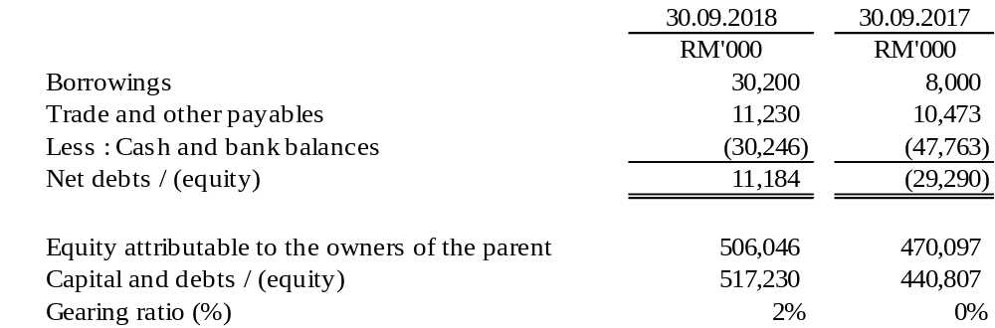

A7 Dividends paid
A final single tier dividend of 6 sen per ordinary share (2017: final single tier dividend 6 sen and special single tier dividend 3 sen) amounting to RM6,536,464.50 in respect of financial year 31 December 2017 was paid on 30 July 2018.

A8 Operating segment information
Segment information is presented in respect of the Group’s operating segments.

The Group comprises the following main operating segments:

- Manufacturing Processing of steel coils into steel products and fabrication of steel products
- Trading Dealing in hardware and construction materials

A8 Operating segment information (Cont’d)
Segment information for the quarter ended 30 September 2018 is as follows:-
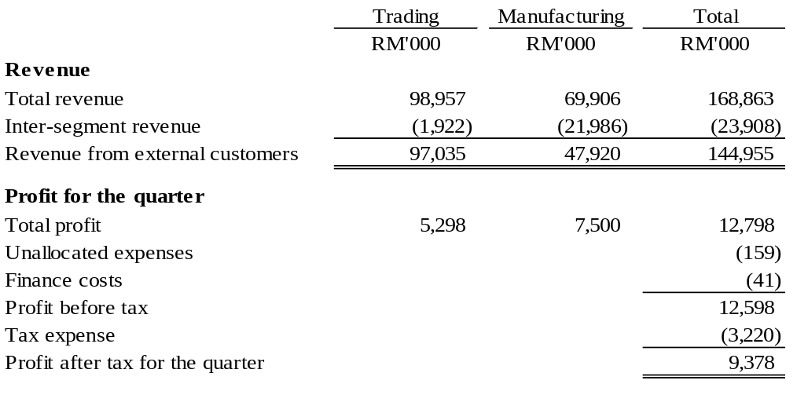

Segment information for the quarter ended 30 September 2017 is as follows:-
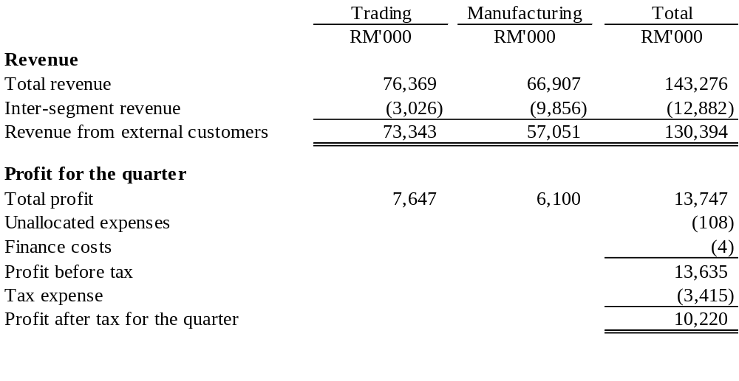

A8 Operating segment information (Cont’d)
Segment information for the financial period ended 30 September 2018 is as follows:-
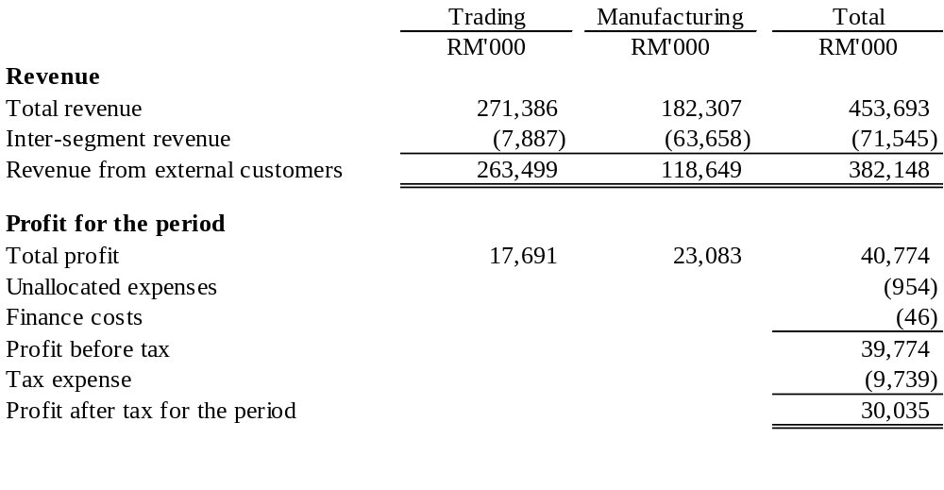
Segment information for the financial period ended 30 September 2017 is as follows:-
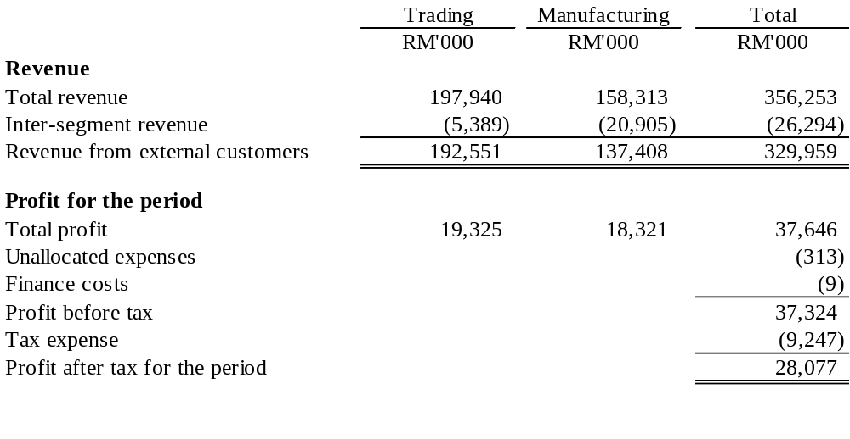

A8 Operating segment information (Cont’d)
Segment assets and liabilities as at 30 September 2018 is as follows:-
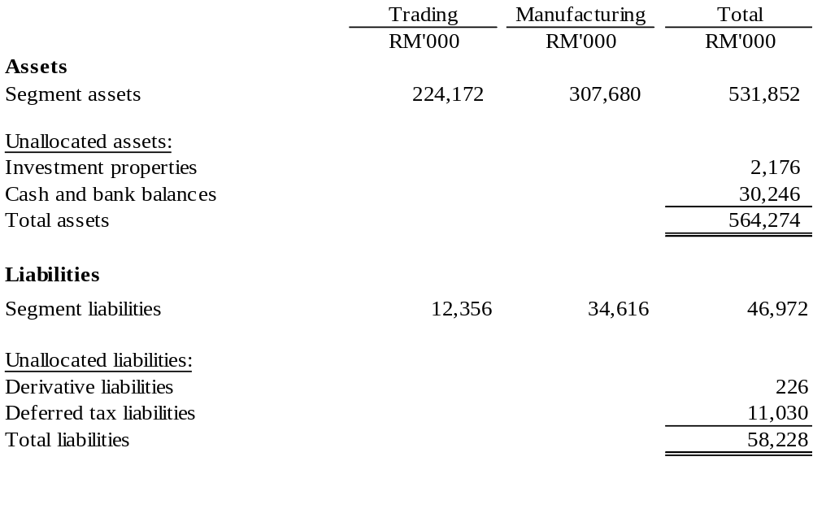
Segment assets and liabilities as at 30 September 2017 is as follows:-
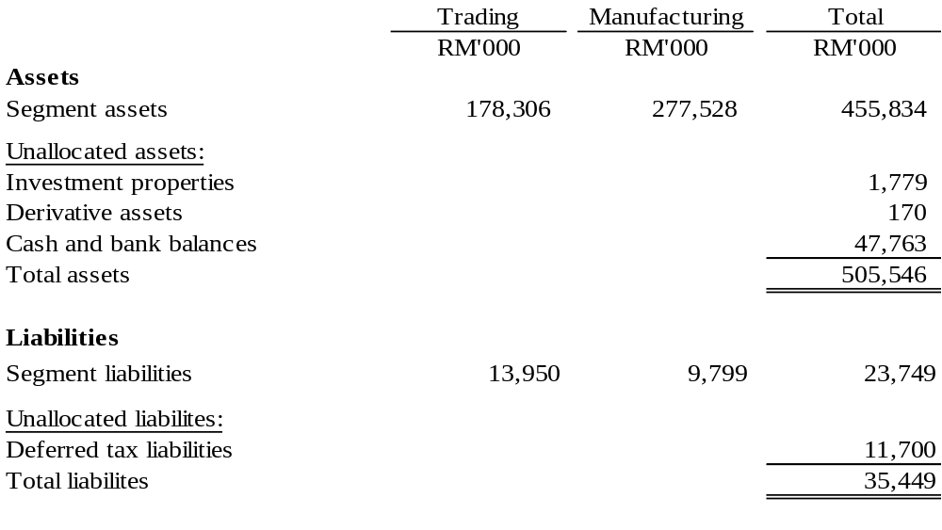
A9 Material events subsequent to the end of the interim period
There was no material events subsequent to the end of the reporting date that require disclosure or adjustments to the interim financial statements.

A10 Significant event during the interim period
The bonus issue proposed by the Company on 26 April 2018 was approved by the shareholders at the Extraordinary General Meeting (“EGM”) held on 22 June 2018. The bonus issue was completed on 31 July 2018 and the details are disclosed in note A6.

Other than the above, there were no other significant events during the period.

A11 Effects of changes in composition of the group
There were no changes in the composition of the Group during the third (3rd) quarter and nine (9) months ended 30 September 2018.

A12 Contingent assets and contingent liabilities
Apart from the corporate guarantees given to financial institution for banking facilities and corporate guarantee given to a third party in respect to sales of good to a subsidiary, there were no other contingent liabilities or contingent assets at the date of issue of the quarterly report.

A13 Capital commitments
Authorised capital commitments not recognised in the interim financial statements as at 30 September 2018 are as follows:
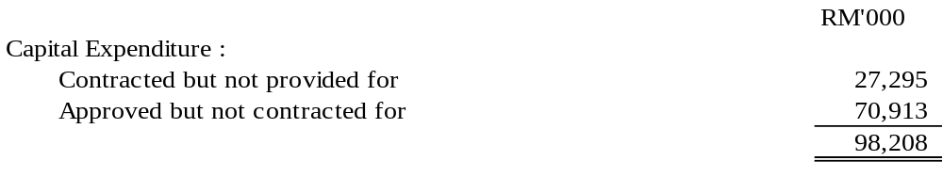
A14 Related party transactions
Related party transactions for the quarter and year to date under review in which certain directors have direct/indirect interest are as follows:

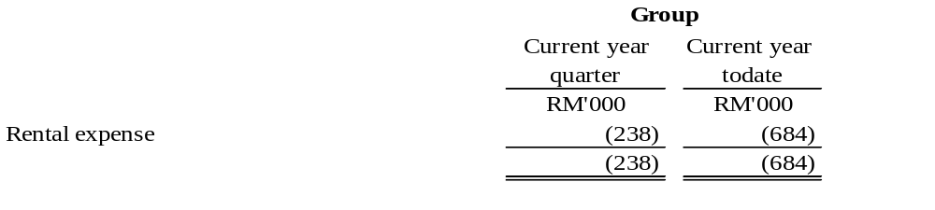
These transactions have been entered into in the normal course of business and at arm’s length basis and on terms no more favourable to the related party than those generally available to the public.

A15 Write down of inventories to net realizable values
Total net inventories written down to either net realizable value or replacement cost for the financial period ended 30 September 2018 was RM106,494.

A16 Financial instruments
- Financial instruments
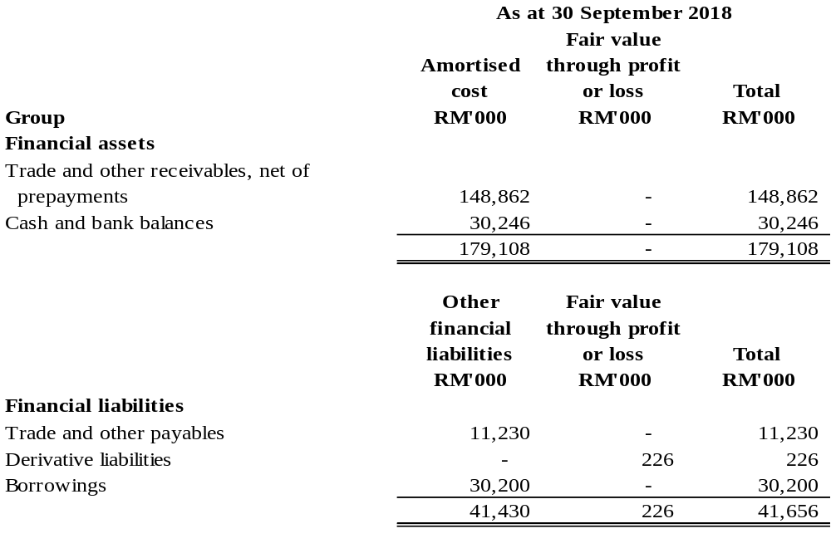Methods and assumptions used to estimate fair value

The fair values of financial assets and financial liabilities are determined as follows:

- Financial instruments that are not carried at fair value and whose carrying amounts are a approximation of fair value.

The carrying amounts of financial assets and liabilities, such as trade and other receivables and trade and other payables are reasonable approximation of fair value due to their short-term nature.

ii. Derivatives
The fair value of a forward foreign exchange contract is the amount that would be payable or receivable upon termination of the outstanding position arising and is determined by reference to the difference between the contracted rate and the forward exchange rate as at the end of the reporting period applied to a contract of similar amount and maturity profile.

iii. Quoted investments
The fair value of quoted investments in Malaysia is determined by reference to the exchange quoted market bid prices at the close of the business at the end reporting period.

A16 Financial instruments (Cont’d)
- Fair value hierarchy
Level 1 fair value measurements are those derived from quoted prices (unadjusted) in active markets for identical assets or liabilities.

Level 2 fair value measurements are those derived from inputs other than quoted prices included within Level 1 that are observable for the asset or liability, either directly (i.e. as prices) or indirectly (i.e. derived from prices).

Derivatives
The fair value of forward exchange contracts is estimated by discounting the difference between the contractual forward price and the current forward price of the residual maturity of the contract using a risk-free interest rate (based on Government bonds).

Level 3 fair value measurements are those derived from inputs for the asset or liability that are not based on observable market data (unobservable inputs).

The following tables set-out the financial instruments carried at fair value is disclosed, together with their fair values and carrying amounts showed in the statement of financial position.

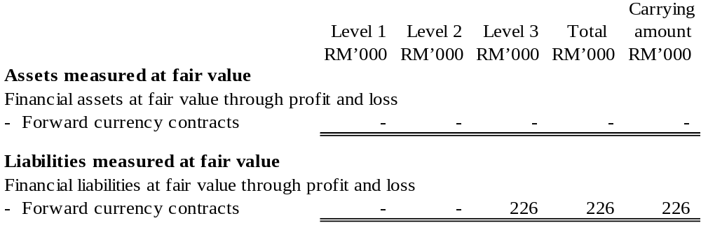There were no transfers between Level 1, Level 2 and Level 3 fair value measurements during the financial period ended 30 September 2018.

- Derivative assets / (liabilities)
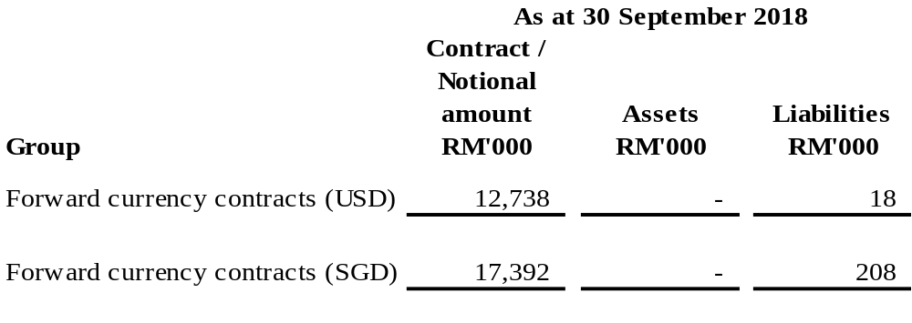

A16 Financial instruments (Cont’d)
- Derivative assets / (liabilities) (Cont’d)
- The Group use forward currency contracts to manage some of the transaction exposure. These contracts are not designate as cash flow or fair value hedges and are entered into for periods consistent with currency transaction exposure and fair value changes exposure. Such derivatives do not qualify for hedge accounting.

- Forward currency contracts are used to hedge the Group’s purchases denominated in USD and sales denominated in SGD for which firm commitments existed at the reporting date, extending to July 2019.

- For the financial period ended 30 September 2018, the Group recognised a loss of RM543,000 arising from fair value changes of derivatives. The fair value changes are attributable to changes in foreign exchange spot and forward rates.

A17 Net assets per share attributable to owners of the Company
Net assets per share (“NAPS”) as at 30 September 2018 stood at RM3.87, a decrease of RM0.57 compared to NAPS of RM4.44 as at 31 December 2017 resulting from the dilutive effect from the issuance of new ordinary shares pursuant to the bonus issue as disclosed in note A10.

EXPLANATORY NOTES : (AS PER MAIN MARKET LISTING REQUIREMENTS OF BURSA MALAYSIA – PART A OF APPENDIX 9B)

B1 Review of the performance of the company and its principal subsidiaries
- Current quarter vs. Previous year corresponding quarter
The Group recorded revenue of RM144.9 million for the quarter ended 30.09.2018 (“3Q 2018”), which rose by RM14.5 million (11%) compared to revenue of RM130.4 million for the quarter ended 30.09.2017 (“3Q 2017”). The stronger performance was mainly attributed to higher contribution from the trading segment.

Despite the improvement in revenue trend, the Group’s profit before taxation softened by RM1.0 million to RM12.6 million for 3Q 2018 as compared to RM13.6 million achieved in 3Q 2017, due to higher raw materials cost and operating expenses compressing profit margins.

The performance of the respective operating business segments of the Group for 3Q 2018 as compared to 3Q 2017 are analysed as follows:

Manufacturing

The manufacturing operations contributed revenue of RM47.9 million in 3Q 2018, which decreased by RM9.2 million (-16%) compared to RM57.1 million in 3Q 2017. The weaker performance was mainly due to softer market demand, as dealers stayed on the sidelines awaiting fresh catalyst from the then impending Budget 2019 announcement.

Trading

The trading operations contributed revenue of RM97.0 million in 3Q 2018, which grew by RM23.7 million (32%) compared to RM73.3 million recorded in 3Q 2017. The stronger performance was due to improved average selling prices and higher metric tonne sales as dealers stocked up inventory prior to the implementation of the Sales and Service Tax (“SST”) regime in September.

- Current year-to-date vs. Previous year-to-date
For the period ended 30.09.2018 (“YTD 3Q 2018”), the Group recorded revenue of RM382.1 million, which strengthened by RM52.1 million (16%) as compared to revenue of RM330.0 million recorded for the period ended 30.09.2017 (“YTD 3Q 2017”). The improvement in performance was mainly contributed by the trading segment.

The Group's profit before taxation for YTD 3Q 2018 was in tandem with the revenue trend and grew by RM2.5 million to RM39.8 million as compared to RM37.3 million recorded for YTD 3Q 2017. The stronger profit margins were further supported by an unrealised gain in foreign exchange trade transactions softening higher operating costs.

B1 Review of the performance of the company and its principal subsidiaries (Cont’d)
- Current year-to-date vs. Previous year-to-date (Cont’d)
The performance of the respective operating business segments of the Group for YTD 3Q 2018 as compared to YTD 3Q 2017 are analysed as follows:

Manufacturing

The manufacturing operations recorded revenue of RM118.6 million for YTD 3Q 2018, which slid by 14% as compared to RM137.4 million in YTD 3Q 2017. The decline in performance was mainly due to a slowdown in market demand, especially for the month of September with the SST implementation and the Government’s decision to cancel or delay some mega projects.

Trading

The trading operations recorded revenue of RM263.5 million for YTD 3Q 2018, which surged by 37% as compared to RM192.6 million in YTD 3Q 2017. The stronger performance was mainly due to higher metric tonne sales volume, particularly for 3Q 2018 as dealers stocked up inventory in anticipation of price increase post SST implementation.

B2 Comparison with preceding quarter’s results
The Group’s revenue for 3Q 2018 improved by 18% to RM144.9 million as compared to RM122.6 million achieved in 2Q 2018. The stronger performance was due to pick up in market demand, mainly from the trading segment as dealers stocked up inventory prior to SST implementation.

However, the Group’s profit before taxation for 3Q 2018 declined by RM0.8 million to RM12.6 million as compared to RM13.4 million for 2Q 2018, due to higher raw materials cost compressing profit margins.

B3 Current year prospects and progress on previously announced revenue or profit forecast
a) Prospects for 2018
The international prices for steel remains soft and it has been decreasing continuously albeit at a gradual pace. However, due to the hefty margins enjoyed by all steel mills there is a risk that prices can suffer a sharp drop if current conditions deteriorate drastically. Due to the escalating trade war and the reduced global economic growth forecast, it is not expected to see any chance of an uptick in demand and prices in the short term. The only positive news for the region is that prices are not significantly disrupted by supply from new sources due to the dearth of sizable orders that make such offers viable.

On the domestic front, steel demand has slowed down since September due to the Government’s cancellation, downsizing or postponement of some mage projects to reduce the country’s national debt. In view of this, steel players have attempted to dump prices to garner replacement for orders lost due to the new directives. However, with the recent announcement of Budget 2019, it appears to benefit the property sector immensely with a variety of measures such as financing of first-time home purchases, stamp duty exemptions and property crowdfunding. This will help the property industry boost sales and clear the supply overhang placing it on a sustainable growth. Such measures once successfully implemented could benefit the steel industry. That being said, the Group’s future success would depend more on water pipes replacement projects, ongoing Governmental Infrastructure projects (MRT2/LRT3) as well as active private sector development projects.

B3 Current year prospects and progress on previously announced revenue or profit forecast (Cont’d)
a) Prospects for 2018 (Cont’d)
In the short term, the Group expects a challenging operating environment. Nonetheless, the Group will continue to focus on improving competitiveness by prudently managing procurement of raw materials, increasing productivity and operational efficiency as well as increase export exposure to soften the impact of headwinds faced.

- Progress and steps to achieve revenue or profit estimate, forecast, projection and internal targets previously announced
There was no revenue or profit forecast announced by the Group.

B4 Statement of the Board of Directors’ opinion on achievability of revenue or profit estimate, forecast, projection and internal targets previously announced
There was no revenue or profit forecast announced by the Group.

B5 Variance of actual profit from forecast profit or profit guarantee
There were no profit forecast or profit guarantee issued by the Group.

B6 Taxation
Tax charges comprise:
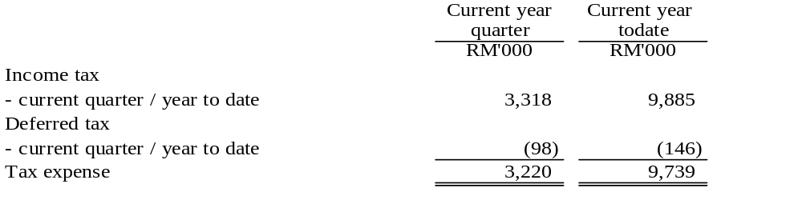
Income tax is calculated at the Malaysian statutory tax rate of 24% of the estimated assessable profit for the period. The effective tax rate for the current quarter and year to date was slightly higher than the statutory tax rate mainly due to the effect of expenses not-deductible for tax purposes.

B7 (a) Status of corporate proposals announced but not completed
There were no corporate proposals at the date of issue of the quarterly report.

(b) Status of utilization of proceeds raised from any corporate proposal
Not applicable.

B8 Group borrowings and debt securities
Details of Group’s borrowings as at 30 September 2018 are as follows:

Short-term borrowings
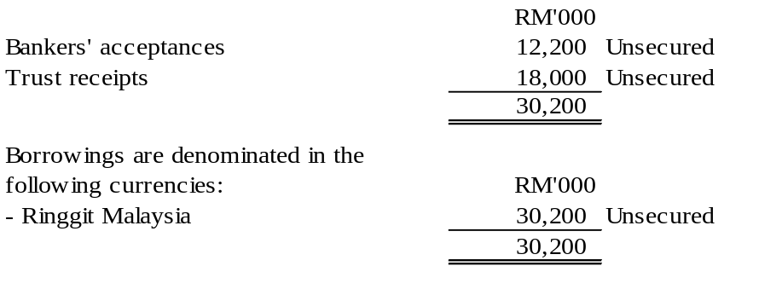
The Group has no debt securities as at 30 September 2018.

B9 Changes in material litigation (including status of any pending material litigation)
There was no material litigation against the Group as at the date of this report.

B10 Dividends proposed
There was no dividend proposed in the current quarter.

B11 Earnings per share (EPS)
(a) Basic earnings per share
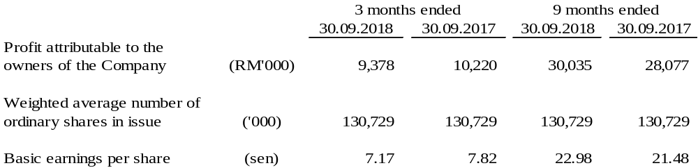

(b) Diluted earnings per share
There are no potential dilutive ordinary shares during the quarter and financial period year to date. Accordingly, the diluted earnings per ordinary share is not presented.

Pursuant to the requirements of MFRS 133 Earnings Per Share, the weighted average number of ordinary shares used in the calculation of basic and diluted EPS above for the current and previous quarters and year-to-date ended 30 September 2018 and 30 September 2017 have been retrospectively adjusted to reflect the bonus issue as disclosed in note A10.

B12 Other income
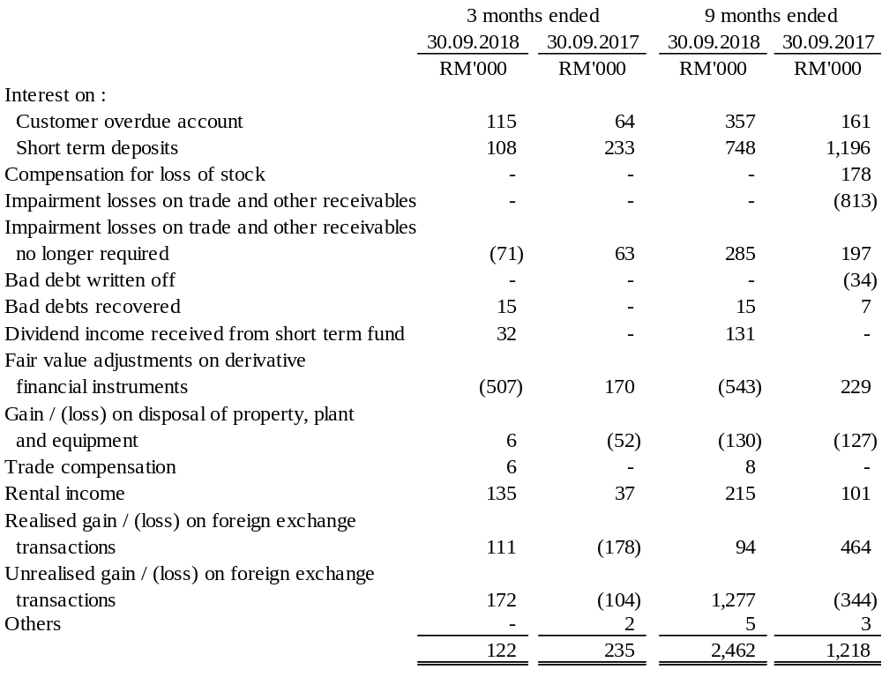
B13 Authorisation for issue
The interim financial statements were authorised on 30 November 2018 for issue by the Board of Directors.

